

# Practices for Secure Software Report

Table of Contents

Document Revision History 3

Client 3

Instructions 3

Developer 4

1. Algorithm Cipher 4

2. Certificate Generation 4

3. Deploy Cipher 4

4. Secure Communications 4

5. Secondary Testing 4

6. Functional Testing 4

7. Summary 4

8. Industry Standard Best Practices 4

## Document Revision History

| **Version** | **Date** | **Author** | **Comments** |
| --- | --- | --- | --- |
| **1.0** | **Feb. 20th, 2024** | **Ryan Hoskins** | **First Update** |

## Client



## Instructions

Submit this completed practices for secure software report. Replace the bracketed text with the relevant information. You must document your process for writing secure communications and refactoring code that complies with software security testing protocols.

* Respond to the steps outlined below and include your findings.
* Respond using your own words. You may also choose to include images or supporting materials. If you include them, make certain to insert them in all the relevant locations in the document.
* Refer to the Project Two Guidelines and Rubric for more detailed instructions about each section of the template.

## Developer

Ryan Hoskins

## Algorithm Cipher

Selecting an algorithm cipher requires many taking many factors into consideration, as different ciphers will be better suited for varying circumstances. A cryptographic hash offers an elegant and effective way for an application to ensure they are properly securing sensitive information, meeting industry regulations, or verifying communications have not been tampered with in transit (Mock, 2023). There are different types of cipher algorithms that function differently, as well. The Advanced Encryption Standard (AES) cipher is an incredibly well-secured option that employs a symmetric structure (Probasco, 2017). However, for the purposes of Artemis Financials’ requirements for verifying data integrity, especially when in transit from their web application, another algorithm cipher would be better suited. Secure Hashing Alogrithm (SHA) offers a hashing algorithm that can be used to verify a digital fingerprint, which allows the system to know that it received exactly what had been sent to them (Griškėnas, 2023). SHA was originally designed by the NSA and provides an option that has not been broken and demands extremely intense resource consumption to attempt to break.

SHA-256 works by outputting 256 bits, which is a fixed size, regardless of the size of what was input. This algorithm cipher provides an effective one-way function that ensures any data that was input will reach its destination without being modified, tampered with, or otherwise changed (Barker, 2020). This is accomplished by ensuring any particular data or input string will result in the same output after being run through the hashing algorithm. Since SHA-256 uses 256 bits, there are 2256 potential hash values, which means the chances of a collision are extremely unlikely (Callaghan, n.d.). Collisions refer to when two different and unique inputs results in the same checksum after being run through the hash algorithm, which would raise security concerns.

There are other forms of algorithm ciphers as well, some which are symmetric or asymmetric. Symmetric algorithms utilize the same key to both lock and unlock ciphered text, a common approach to encrypting stored data (Simplilearn, 2023). On the other hand, asymmetric algorithms utilize more than one key. There will be a key to encrypt the data, another to decrypt the data, meaning it utilizes a private and public key combination to ensure data is kept secure. Another method often employed to ensure security in encryption algorithms is to utilize random numbers, or random bit generators (RBG). This method is often used during the creation of a key, ensuring any numbers used are random and much more difficult to crack than if a key were created without randomized bits (Baker, 2020).

## Certificate Generation

Insert a screenshot below of the CER file.

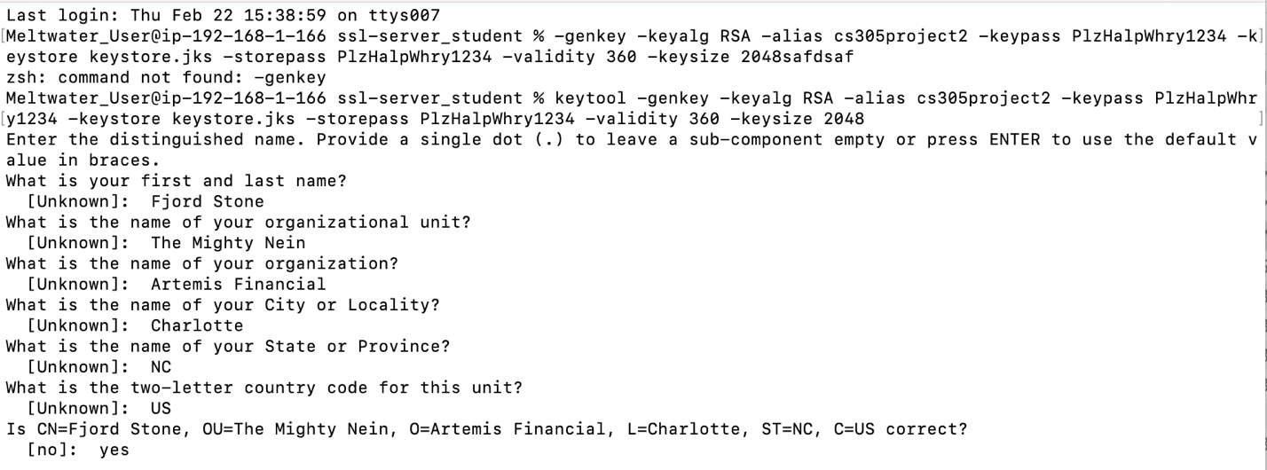

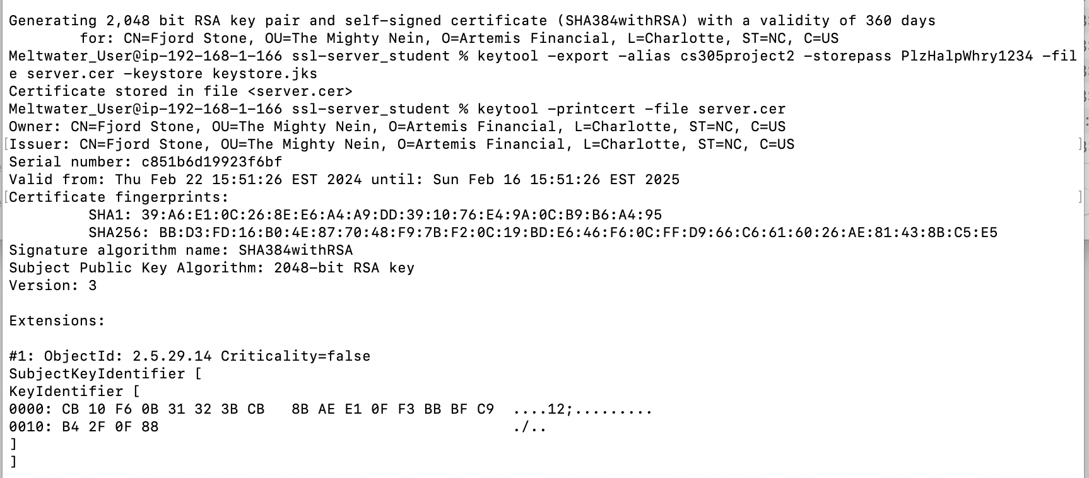

[Insert screenshots here.]

## Deploy Cipher

Insert a screenshot below of the checksum verification. 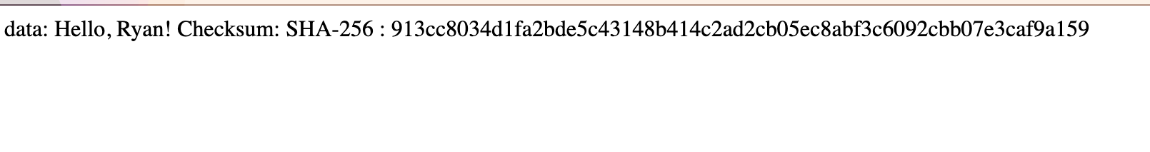

## Secure Communications

Insert a screenshot below of the web browser that shows a secure webpage.

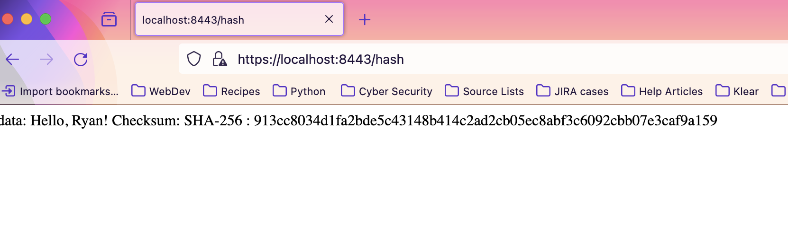

## Secondary Testing

Insert screenshots below of the refactored code executed without errors and the dependency-check report.

First Dependency Check:

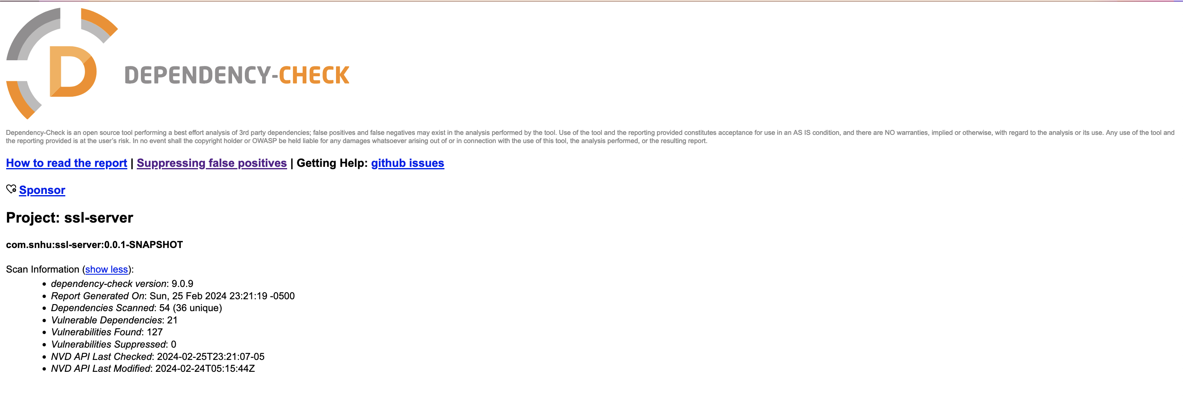

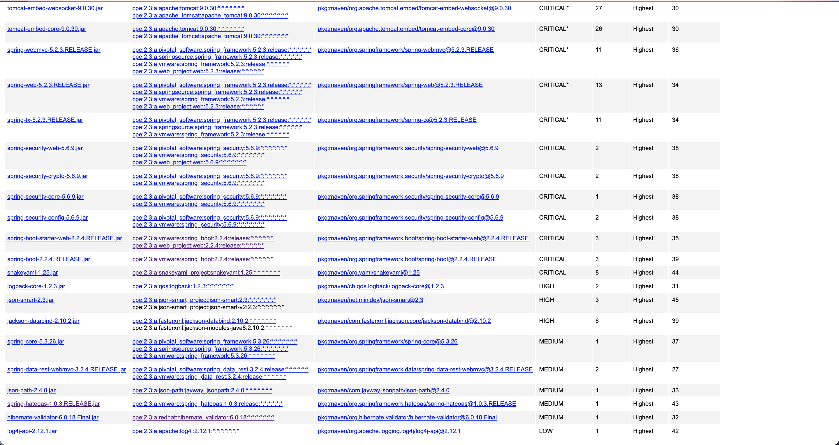

SslServerApplication.java:   
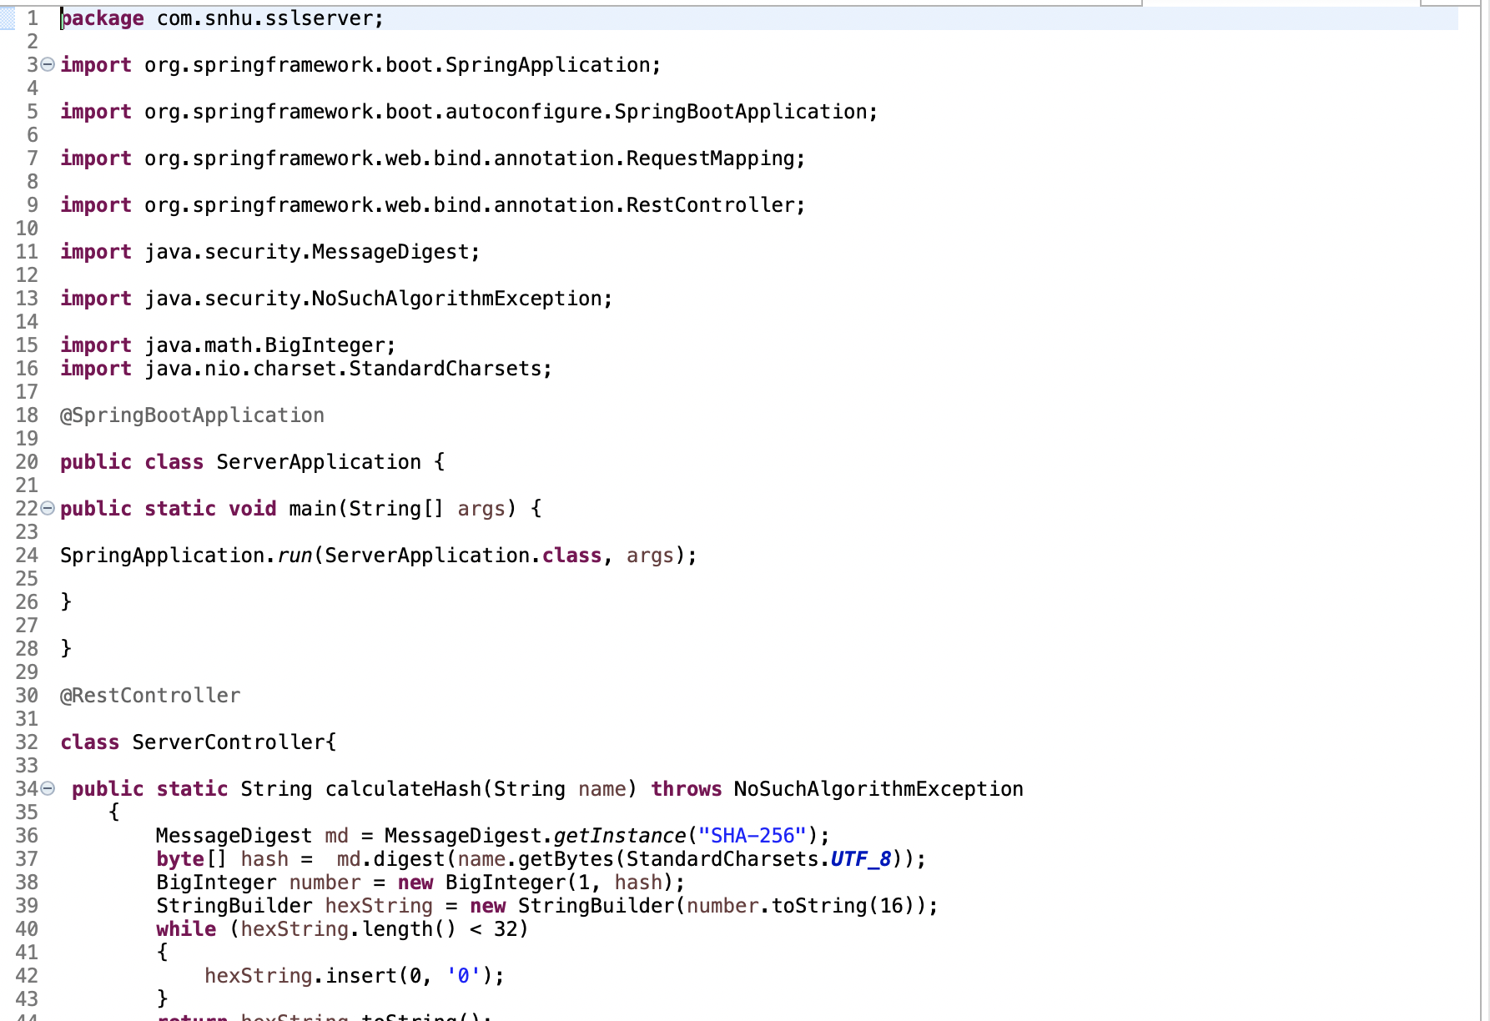  
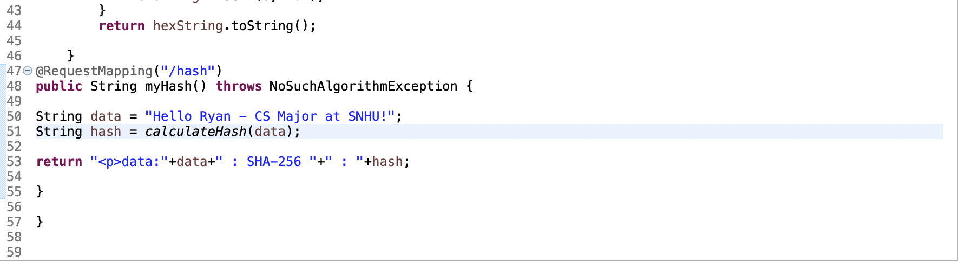

Pom.xml:  
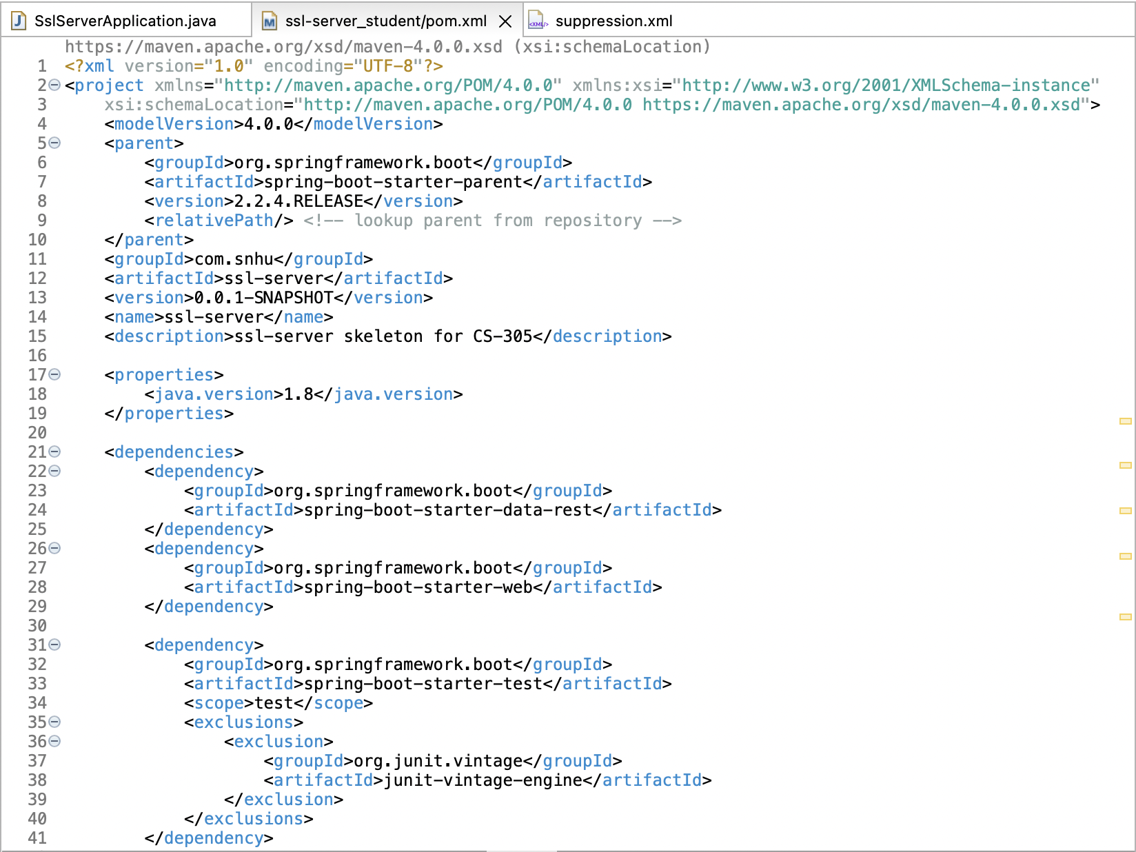 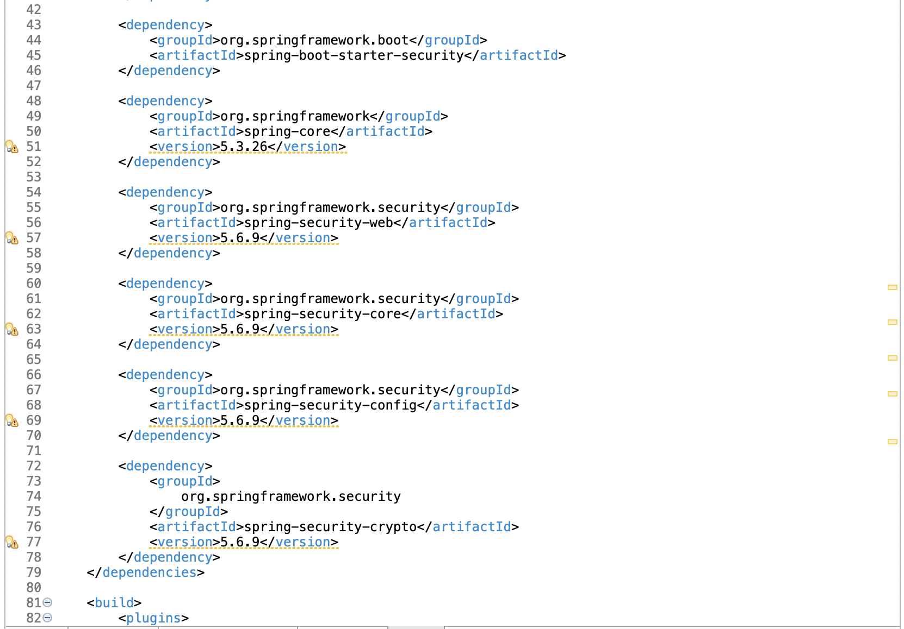  
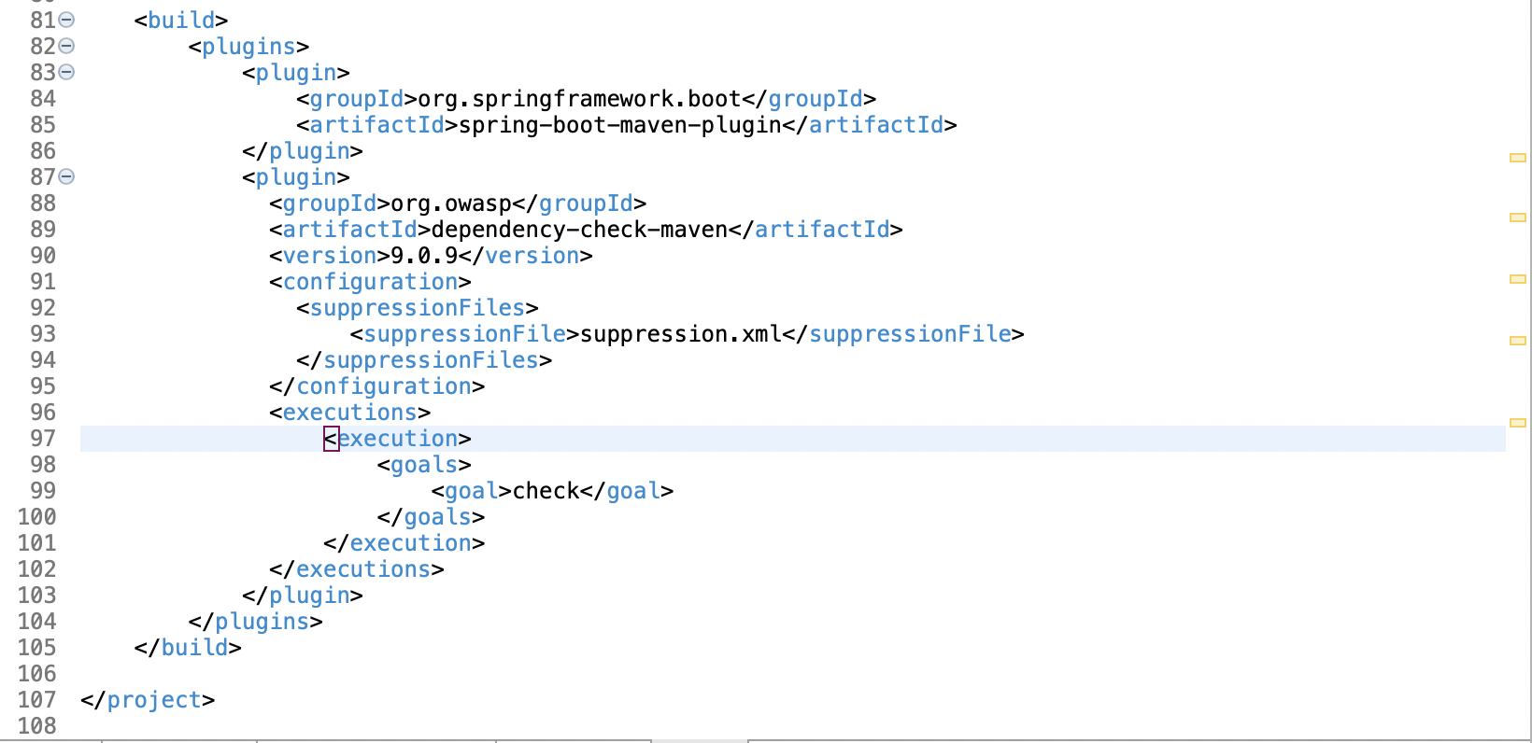

Suppression.xml  
  
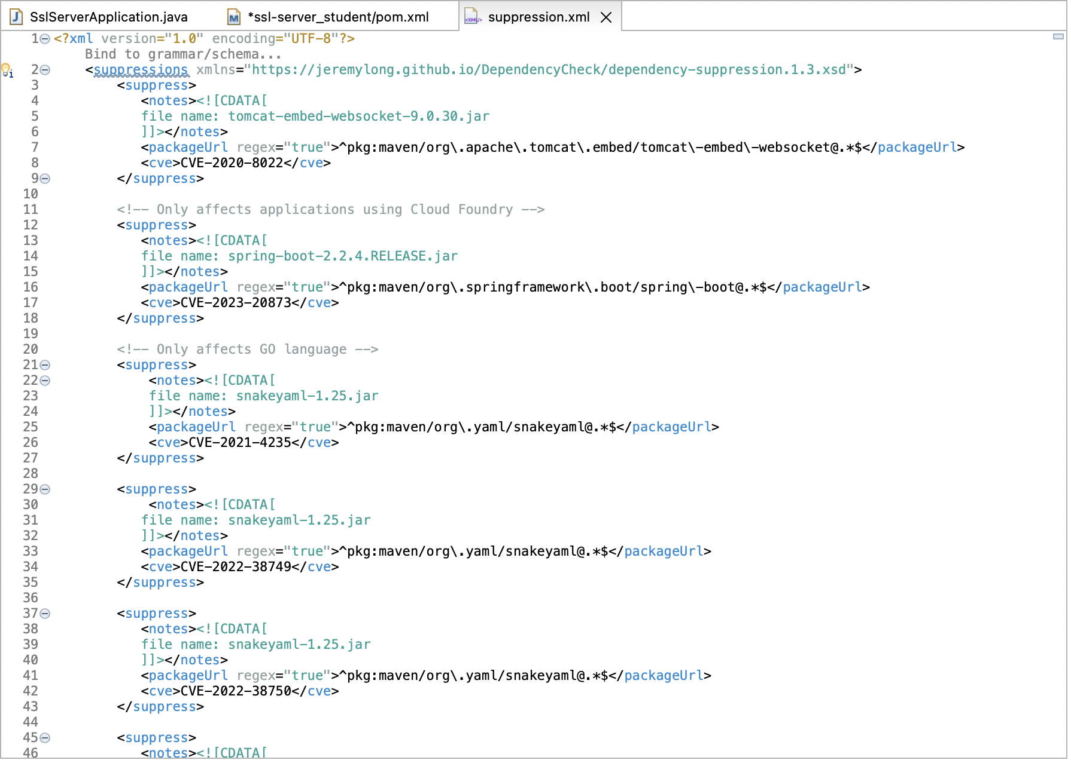 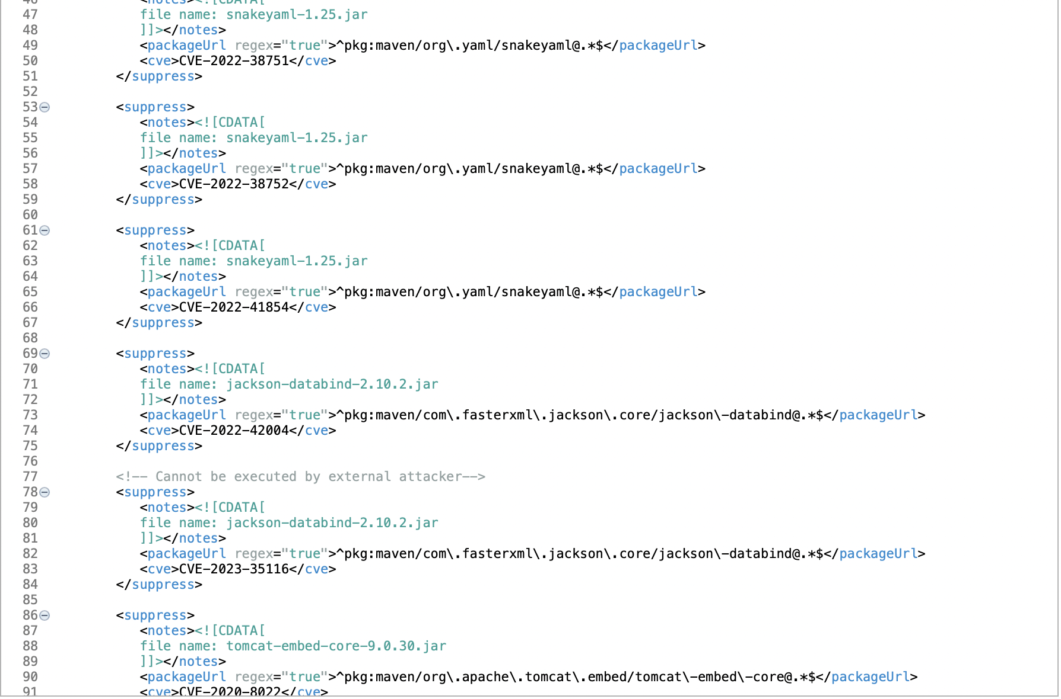  
application.properties:  
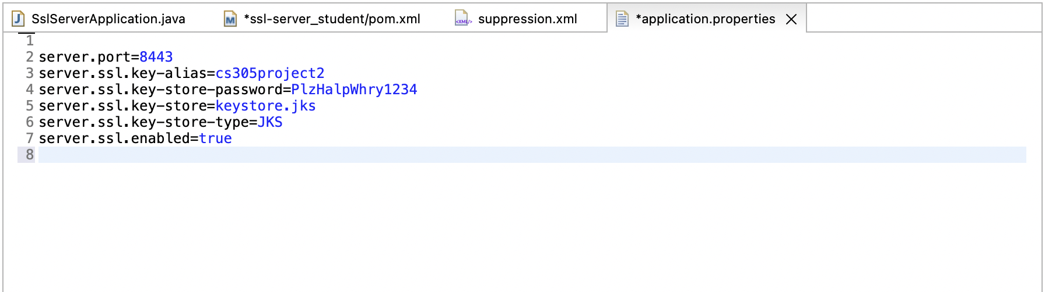

Second Dependency Check:  
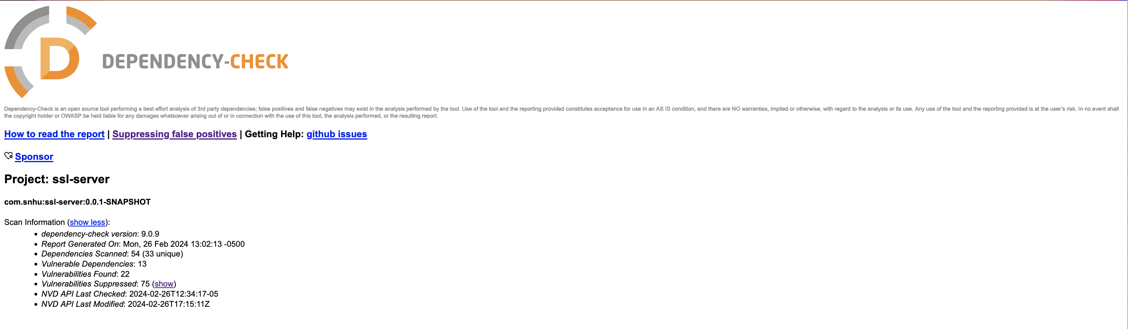 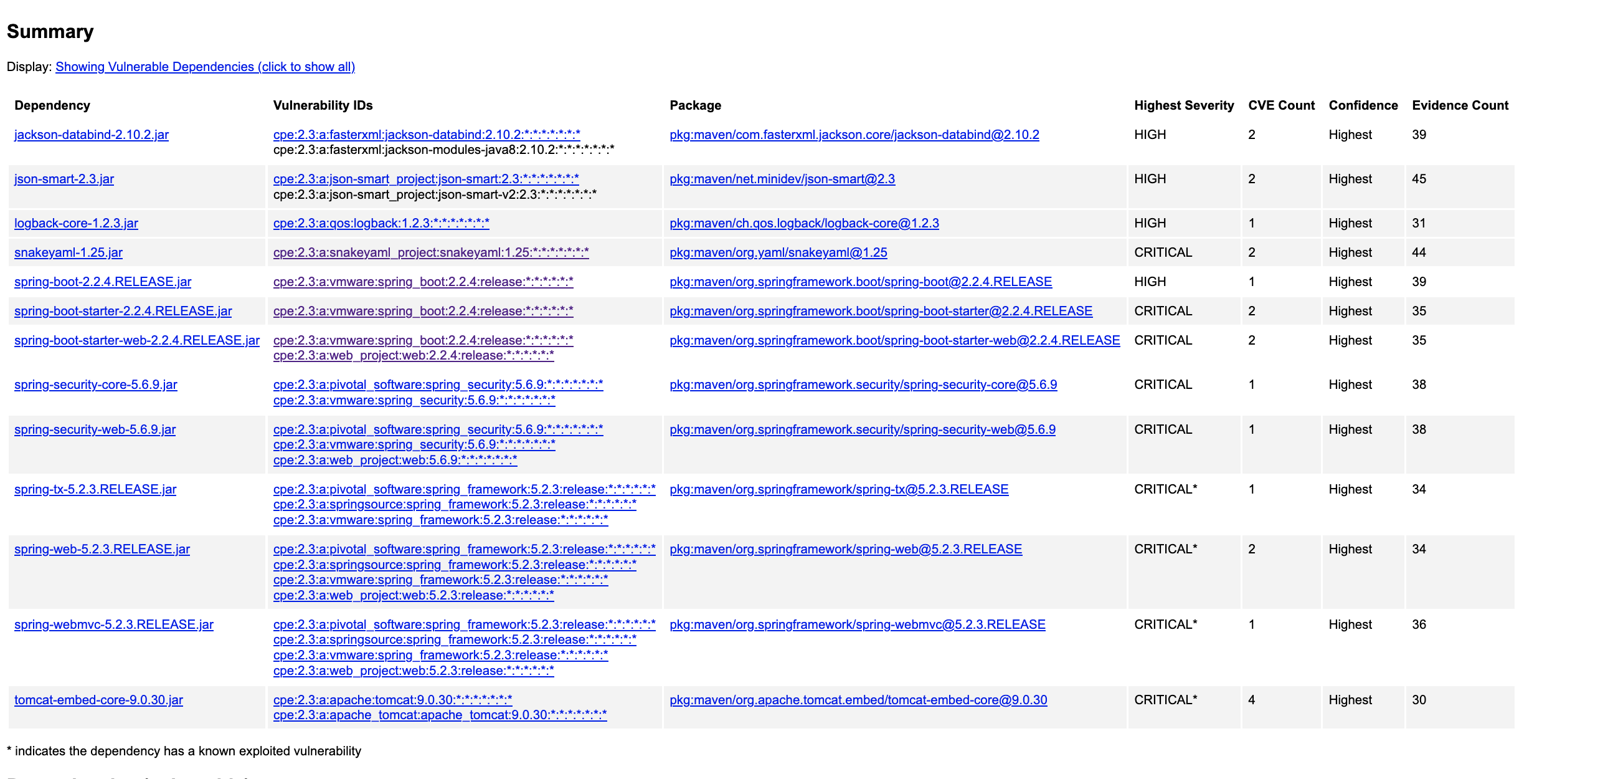

## Functional Testing

Insert a screenshot below of the refactored code executed without errors.

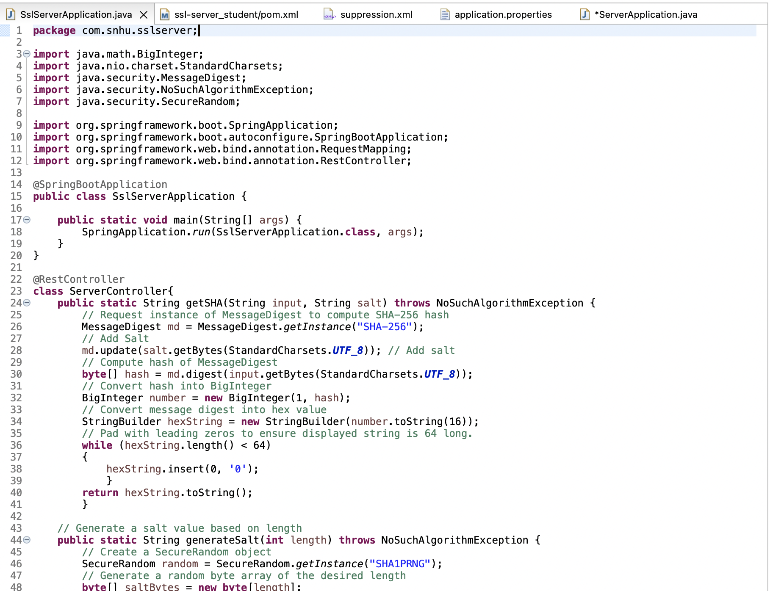  
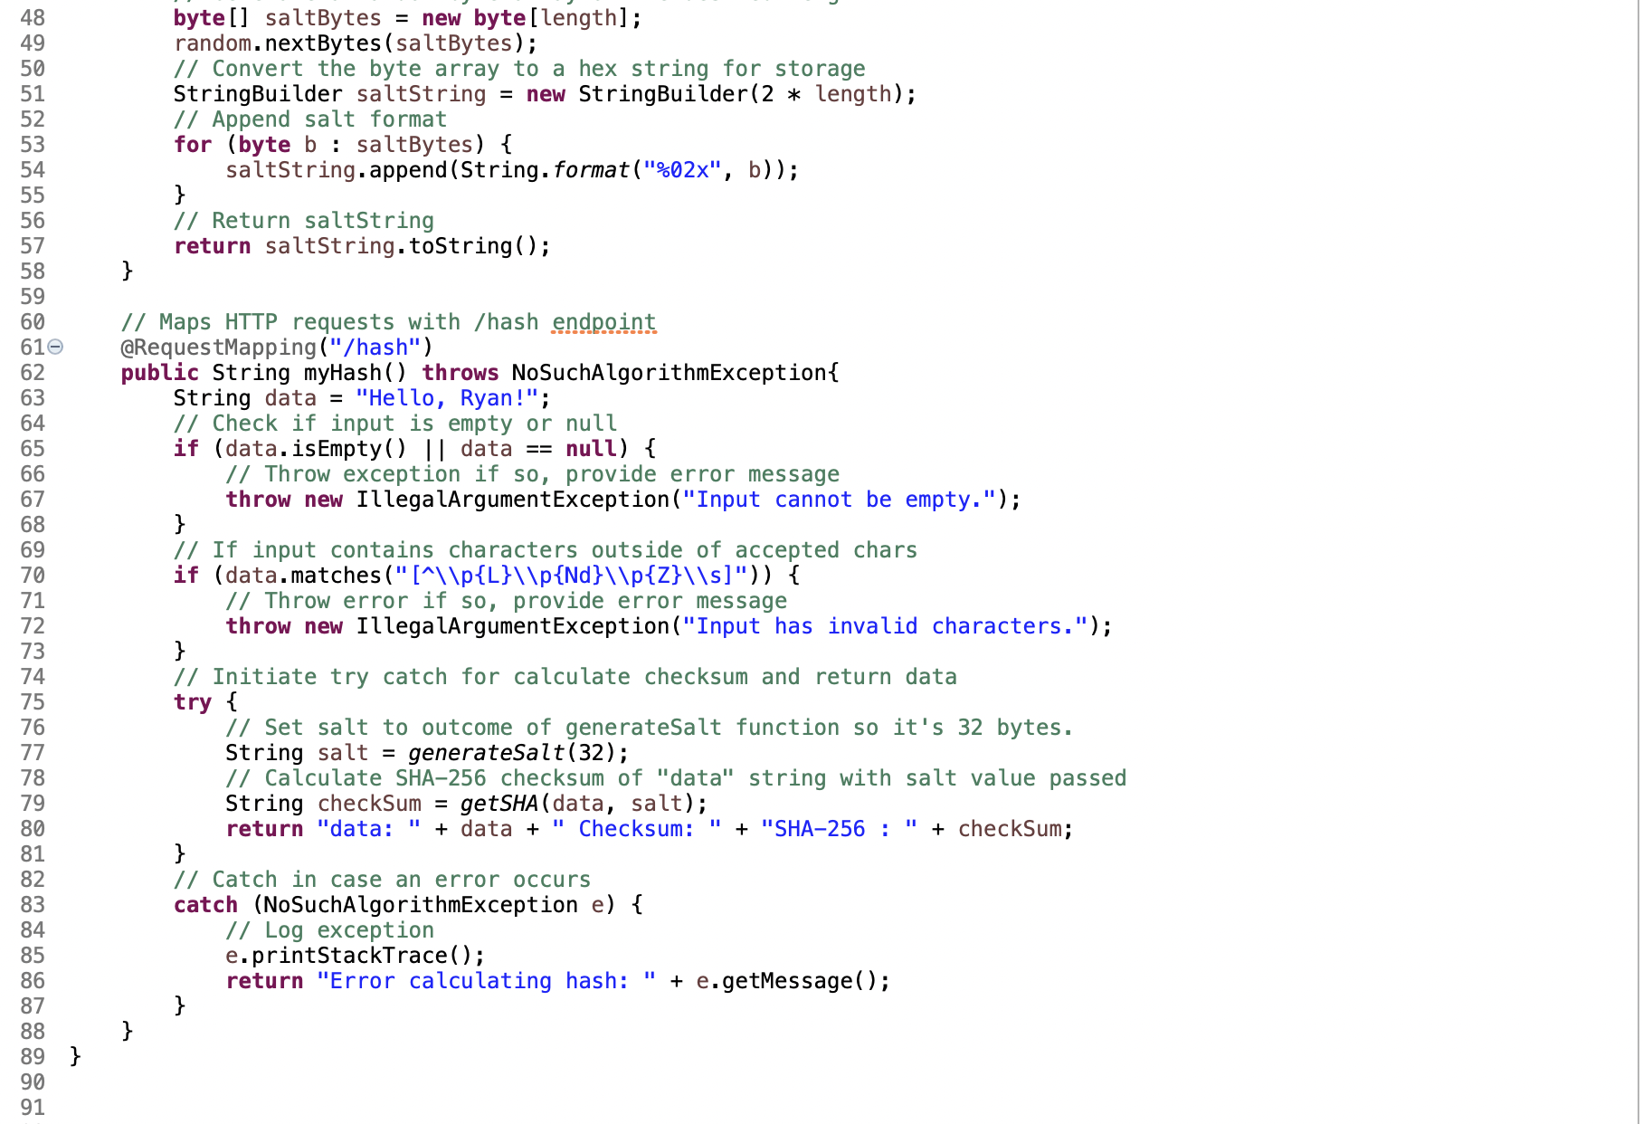

## Summary

The initial area of concern in the application was to address the lack of cryptography present in the application. As a financial institution, Artemis Financial is likely to be held accountable by government regulations or policies that mandate a certain level of security for potentially sensitive information. Specifically, it is important that some form of cryptography be used for data, whether in transit or at rest. To address this need, a variety of techniques were employed to bolster the cryptographic strength of the program. A checksum was introduced by utilizing the MessageDigest class. This MessageDigest class utilizes Secure Hashing Algorithm (SHA), specifically SHA-256, that hashes the data. To ensure a “digital fingerprint” could be created to ensure the message was not altered, the hashed data is converted into a hexadecimal string. To further strengthen the cryptography used in this application, Salting was also employed. By introducing additional random data to input data before it gets hashed, Salting makes the process of cracking a password much more difficult (Hughes, 2022). The salt value gets appended to the end of the data, or password, before it gets hashed, which helps ensure the hash value of the data or password itself is hidden, as only the salted hash is shown.

The application’s security was also enhanced through Secure Input and Validation. The cryptographic measures implemented do help bolster this area of security as well, but the code implemented can also be utilized for securing input. While the program itself is not currently set up to take user input, there is programming that can utilized once the application is modified to accept user input. One such example of this can be found here:  
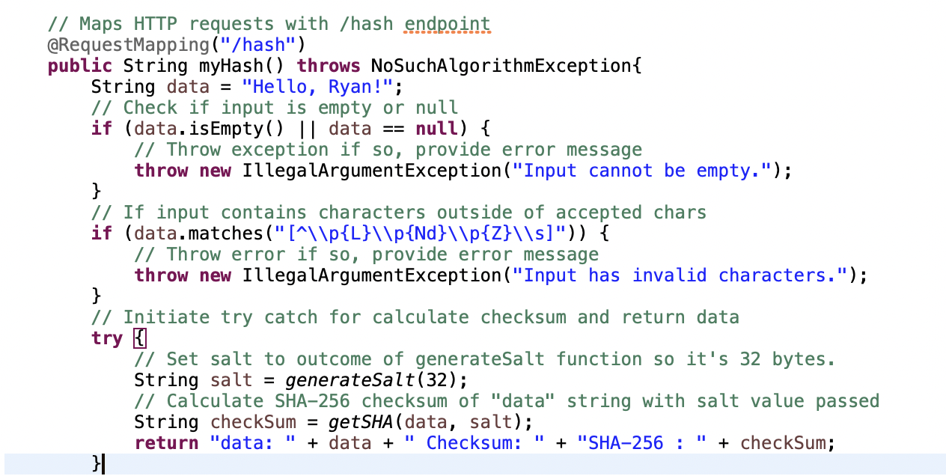

By checking if data, or user input, is empty or null or contains certain characters that could be used in an attempt to inject malicious code, the application employs secure input validation and validation.

Lastly, the application will only utilize Port 8443 and accept traffic initiated with HTTPS. This was accomplished by adding to the application.properties file in the application. A self-signed certificate was created and stored in the application, allowing a visitor to know they are visiting the legitimate site through HTTPS. This is important, as HTTPS provides an additional layer of security for the communication between a browser and the server (Crane, 2023).

## Industry Standard Best Practices

As a advising business in the financial sector, Aretmis Financial is held accountable to many government regulations and policies that mandate a certain level of security be upheld. As a business that relies on clients trusting their financial advice and that Artemis Financial has their best interest in mind, they require a strong level of trust from their clients. While Artemis Financials’ business may focus on financial counseling, the decisions made in the way in which they conduct business will have a profound effect on existing and potential clients. Not only is it essential for Artemis Financial to exhibit sound financial advice, but it is crucial they demonstrate their willingness to protect and secure their clients sensitive data while abiding by policies put in place to protect consumers.

To instill a strong sense of trust in their clients, it is important that Artemis Financial use industry best practices for their web application. By utilizing a method to validate user input through, the application bolsters its defenses against both malicious code injection as well as unexpected behavior from invalid input from a user. Another important practice is securing and encrypting sensitive data. The application utilizes secure HTTPS communication, which is essential for a web application as it ensures data is encrypted in transit, whether it be a user’s entered password or their personal data. Important data is further secured using a hash function, salting, and a checksum. SHA-256 is a widely accepted and considered an effective method to secure data from a security breach or cryptographic attack (Griškėnas, 2023). This is further strengthened by salting the hash function, making it even more difficult to breach or crack. By utilizing a checksum, Artemis Financial has a method for verifying the integrity of the data sent and received over secure channels.

Secure coding practices ensure their client’s data remains confidential and its integrity upheld, which will build confidence within their client in the services the business offers. By ensuring security best practices are upheld, Artemis Financial mitigates the risk of legal recourse from potential data breaches as well as the damage to their reputation in the industry (Firch, 2023). Maintaining a secure web application is an essential investment in the business, as it not only presents Artemis Financial as a respectable and serious brand, but also prevents the fallout and damage that would incur from a security breach.

References

Crane, C. (2023, May 25). *What is a hash function in cryptography? A beginner’s guide*. Hashed Out by the SSL StoreTM. <https://www.thesslstore.com/blog/what-is-a-hash-function-in-cryptography-a-beginners-guide/>

Crane, C. (2023a, March 31). *Is HTTPS secure? A look at how secure HTTPS is*. Hashed Out by the SSL StoreTM. https://www.thesslstore.com/blog/is-https-secure-a-look-at-how-secure-https-is/

Firch, J. F. (2023, January 13). *Top 10 Cyber security benefits in business*. PurpleSec. Retrieved February 21, 2024, from https://purplesec.us/learn/cyber-security-benefits/

Griškėnas, S. (2023, September 1). *What is the SHA-256 algorithm?* NordVPN. <https://nordvpn.com/blog/sha-256/>

Hughes, A. (2022, March 1). Encryption vs. Hashing vs. Salting - What’s the Difference? *Ping Identity*. Retrieved February 21, 2024, from https://www.pingidentity.com/en/resources/blog/post/encryption-vs-hashing-vs-salting.html

Manico, J., & Detlefsen, A. (2014b). *Iron-Clad Java: Building secure web Applications (Oracle Press)* [Online Textbook]. McGraw-Hill Education. http://dl.acm.org/citation.cfm?id=2826076

McKeever, G. (2022, April 20). *The top 3 OWASP risks to the financial services sector in 2021 and how to mitigate them | Imperva*. Imperva. Retrieved January 25, 2024, from <https://www.imperva.com/blog/the-top-3-owasp-risks-to-the-financial-services-sector-in-2021-and-how-to-mitigate-them/>

Mock, M. (2023, October 9). *7 industry sectors that need data encryption*. Kiteworks | Your Private Content Network. Retrieved February 2, 2024, from <https://www.kiteworks.com/cybersecurity-risk-management/industry-sectors-data-encryption/>

Probasco, L. (2017, April 17). *Encryption requirements for banks & financial services*. Townsend Security. Retrieved February 2, 2024, from <https://info.townsendsecurity.com/encryption-requirements-for-banks-financial-services>

PurpleSec. (2023, January 13). *Top 10 Cyber security benefits in business*. https://purplesec.us/learn/cyber-security-benefits/

Simplilearn. (2023, August 29). *What is data encryption: types, algorithms, techniques and methods*. Simplilearn.com. https://www.simplilearn.com/data-encryption-methods-article#what_are_the_2_types_of_data_encryption_techniques